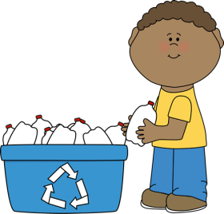
Plastics-Clean out food/liquid
**SMALL MOUTH BOTTLES ONLY **

A bottle is defined as a container that has a smaller opening than the circumference of the container.

#1 PETE– Water,Soda,Juice Bottles
#2 HDPE CLEAR – Clear Milk Jugs
#2 HDPE COLORED-ie. Detergent Bottles, Coffee Containers, etc.
PLEASE REMEMBER TO -
RINSE OR WIPE CLEAN ALL FOOD AND RESIDUE FROM BOTTLES
++++++++++++++++++++++++++++++++++++++++

EXCLUSIONS:

* ALL BLACK COLORED PLASTIC *

CONTAINERS THAT HELD WASTE OIL, PESTICIDES OR CLEANING PRODUCTS- NO MEDICAL WASTE

********************************************
ALL OTHER PLASTIC NOT LISTED ABOVE BELONGS IN THE TRASH!!

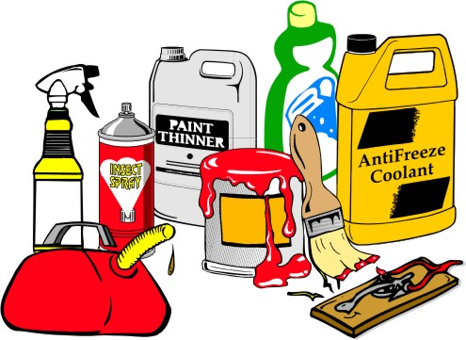
* Fee Schedule *
Payment by Cash, Check, Debit/Credit

MUST SCALE IN FOR…..
Mixed Garbage – Trash bin lower floor
Construction Debris – Dump Trailers Only –
Use Bunker #2 out back
All Other Construction Debris – Box #3 out back

(.10 cents/lb.) $200.00 per ton

Tires – Box #1 out back
Up thru 19.5” rim size - $ 3.00 each
20” rim thru 24.5” rim size - $ 7.00 each
Equipment Tires - $75.00 each

Mattresses / Box Springs-Trash bin lower floor
All sizes - $5.00 each

Bulky furniture – Trash bin lower floor
Couch/Sleep Sofa, Stuffed Chairs - $10 Each

Paint – weighed on the lower floor scale
$4/gallon - $ .45 cents/lb

Antifreeze-pallet lower floor
$1.00 gal

TV’s/Monitors/Laptops/Tablets-bin lower floor
$20.00 per unit

Refrigerators, A/C units, etc. -alleyway side bldg.
$10.00 per unit

Propane Tanks -cages in front of #5 metal box
Up to 20 lbs $ 5.00 each tank
100 lb tanks NOT ACCEPTED

B.C.E.P. Solid Waste

2019

Waste Disposal & Recycling
for the towns of

Barnstead
Chichester
Epsom
Pittsfield
_____________________________
* Facility Hours *
Open
8:00 A.M. to 4:00 P.M.
Tuesday, Wednesday, Thursday, Friday & Saturday
Scales close at 3:45 P.M.
Closed Sunday & Monday

* 2019 Holiday Schedule *
The facility will also be closed for the following Holidays.
New Year’s Tuesday January 1st
Memorial Day Tuesday May 28th
4th of July Thursday July 4th
Labor Day Tuesday September 3rd
Thanksgiving Thursday 28th & Friday 29th
Christmas Tuesday 24th & Wednesday 25th

BCEP Solid Waste District
PO Box 426 - 115 Laconia Road
Pittsfield, NH 03263-0426
603-435-6237
www.bcepsolidwaste.com
* Why Recycle? *

Separation of materials for recycling has been mandatory at the solid waste facility since 1990. If all recyclable products are not removed from your garbage you must pay for disposal.

PLEASE SORT AT HOME FIRST
New guidelines for separation and contamination of recyclables. All items must be free of food residue, liquids and grease. Think “Clean in the Recycle Stream”. We cannot sell product to the market that does not meet strict contamination guidelines. Rejected loads are very costly to the District. Dirty recyclables end up in the trash. So please help us keep costs down and revenue flowing by RINSING AND SORTING AT HOME FIRST.

Each ton of waste we send to a landfill costs the taxpayer approximately $75.00 in disposal and transportation fees. Each ton of material we recycle saves this fee and also generates revenue back to the taxpayer, as shown below.

*Tax Savings from Recycling*

Tons Tax

Year Recycled Offset
2014 1,038.3 $173,541.02
2015 1,256.5 $168,057.14
2016 1,233.2 $213,331.38
2017 1,210.7 $190,598.43

* Separation Guidelines *

Automotive Wastes-pallet lower floor
Lead Acid Batteries/Oil/Antifreeze

Cans – Aluminum-upper recycling floor
Clean Aluminum Beverage Cans Only

Cans – Tin-upper recycling floor
Clean Tin, vegetable & pet food cans & foil

Clean Dry Cardboard-upper floor
Corrugated boxes. No wet, soiled, waxed, foiled or plastic-coated cardboard.

Demolition-Fee Item-Check Fee Schedule
Shingles, sheet rock, masonry, painted, treated or manufactured wood, wood over 5” etc.

Electronics-Fee Item-lower floor
Computers, Monitors, TV’s, All Electronics

Glass-upper recycling floor
Glass bottles, ceramics, china

Metal-Box #4 & Box #5 out back
All metal items except refrigerant units.

Mixed Paper-upper recycling floor
Any reasonably clean paper product
including newspaper and books. No soiled, waxed, foil or plastic-coated papers.

Paint-Fee Item-SEE STAFF- lower floor
Oil or latex in original containers

Plastic Bottles ONLY
Clean #1 and #2 Plastic Bottles – All other plastic goes in the trash.

Vegetable Oil -pallet lower floor
All except linseed

Brush and Yard Waste
Not accepting at this time.

Cell phones – Ink Cartridges- Box Tops
Table along the office window ______________________

* Burn Pile *

The Brush Pile and the Leaf/Yard Waste Areas on the hill are temporarily shut down. No material is being accepted at the facility at this time. Please check in the office for alternative locations.

* Other Items *

Hypodermic Needles: Please put in a hard container (i.e. coffee can, milk jug, detergent bottle) securely tape the top shut (duct tape works well) mark it Sharps and bring into the Office. We cannot accept Red Bio-Hazard Containers.
Batteries: Alkaline-put in the trash. Rechargeable & Button batteries should be brought into the Office. Lead Acid – lower floor.
Fluorescent Bulbs & Small Appliances: Please place in the marked boxes on the lower transfer floor. Ask a staff member if you are not sure where they go.
Mercury Containing Items: Includes Thermometers, Thermostats or any item you suspect. Bring into the Office.

Additional Trivia

The annual property tax raised to operate the District facility for 2018 works out to $45.12 per resident for the year.
If you have comments or suggestions regarding our efforts, please express them to the staff.
Lisa Stevens
District Administrator
________________________________

